SIMply Retailer API
(Elite Mobile – V3)
URL:

https://api.simply.elitemobile.com/

Security / Authentication:
https://api.simply.elitemobile.com/GenerateToken
POST API
SIMply will provide credential, which you need to be passed in each Token API call request for security reason.
Credential includes, “Username”, “Password”, “ClientId” and “ClientSecret”
grant_type will be always a static value that is “password”.
Here, Username and Password will be your User Account details through which you are doing login in to SIMply Web or App.
ClientId and ClientSecret will be provided by your SIMply account manager.

We have setup for Test and Production Environment.
So ClientId and ClientSecret will be different for both Test and Product Environment.
Same URL will be used for Test and Product Environment, just based on your ClientId and ClientSecret, SIMply will identify the which environment you are looking for.
For testing purpose or test environment, you should use Test ClientId and ClientSecret.
Token will be expired in every 15 minutes. So, you need to generate token again if its invalid token.

In Request Header, you will need to pass “Content-Type” having value “application/x-www-form-urlencoded”
Here, “expires_in” is in seconds. 899 seconds equal to 15 minutes.
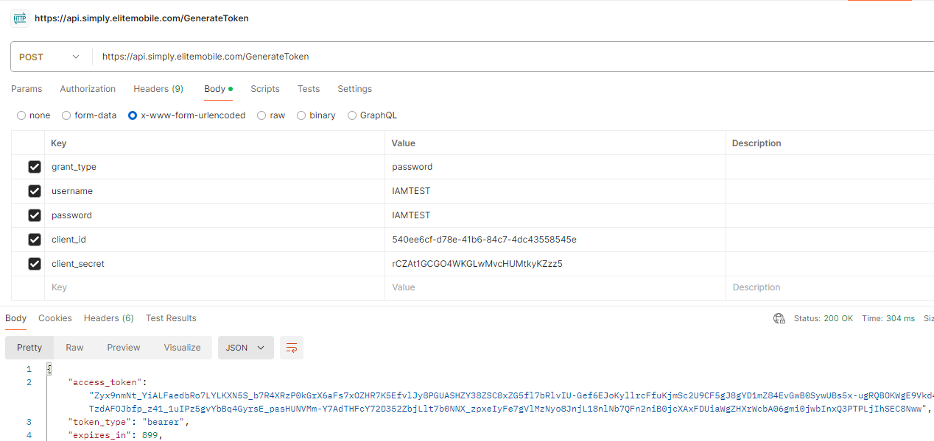

You will receive new Token on GenerateToken API call. You need to pass that newly generated Token in header while other API call request.
Ex:
Header should be,
Key: Authorization
Value: bearer token
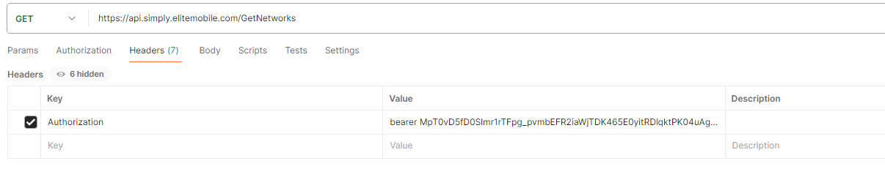

Please don’t share your password to anyone and don’t keep it visible on browser while requesting so that anyone can see through browser tool.

Responses / Messages
Status: 1 (Success) or 0 (Failure)
Message: API wise case wise different messages.

ESIM
List of API for ESIM
- GetESIMCountries
- GetESIMBundles
- OrderESIM
- ViewESIMOrderDetails
- RevokeESIMOrder

GetESIMCountries:
GET API.
https://api.simply.elitemobile.com/GetESIMCountries
You will receive Network list available in SIMply with Region and Image details.
API will not need any Parameters. Its just need token to be passed in Header generated through above GenerateToken API.
Access Token can be passed only in header and cannot be passed in the request param.
Header name should be “Authorization”
Header value should be bearer {access_token}

you need to pass “Authorization” having value “Bearer (Token Received)”.
“Content-Type” having value “application/json”
Here, Bearer is fixed word then space then Token received in Token API.

Request and Response would be in JSON Format.
Possible Responses
{
"Status": 0,
"Message": "Invalid Token",
"PageCount": 0,
"PageSize": 0,
"Rows": 0,
"TotalPages": 0
}
Response Code: 401

{
"CountryList": [
{
"CountryName": "Afghanistan",
"Emoji": "🇦🇫",
"Region": "",
"CountryISO": "AF",
"CountryImage": "https://simply.elitemobile.com/Content/Images/CountryIcons/AF.png"
},
…….
],
"Status": 1,
"Message": "Success",
"PageCount": 1,
"PageSize": 0,
"Rows": 275,
"TotalPages": 0
}
Response Code: 200
Success ("Status": 1)
- Success
Failure ("Status": 0)
- Out Of Service. Please contact your administrator.
- You are not allowed for ESIM. Please contact your administrator.
- Invalid Account Details
- No Data Found.
Response Code: 200

GetESIMBundles:
POST API.
https://api.simply.elitemobile.com/GetESIMBundles
You will receive eSIM Bundle list available in SIMply with details.
Token need to be passed in Header generated through above GenerateToken API.
“Content-Type” having value “application/json”
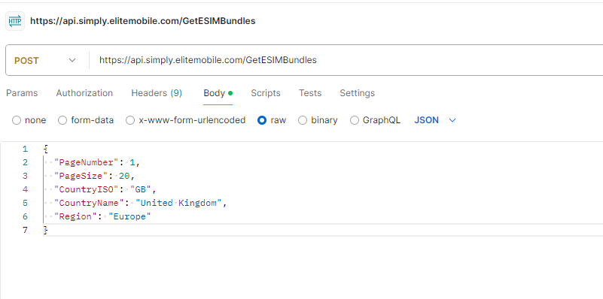

Request and Response would be in JSON Format.
Possible Request
POST Object.
{
"PageNumber": 1,
"PageSize": 20,
"CountryISO": "GB",
"CountryName": "United Kingdom",
"Region": "Europe"
}

PageNumber: | int value that you want to see as current page.
PageSize: | int value the number of records you want to see together. Ex. 10, 20, 50, 100, 500  Note: Default is 20
CountryISO: | Optional. It will help to filter by country you want to see bundle list by unique country ISO. You can get it from GetESIMCountries API.
CountryName: | Optional. It will help to filter by country you want to see bundle list by country name. You can get it from GetESIMCountries API.
Region: | Optional. It will help to filter by region you want to see bundle list. Ex Europe, Asia You can get it from GetESIMCountries API.

Possible Responses
{
"Status": 0,
"Message": "Invalid Token",
"PageCount": 0,
"PageSize": 0,
"Rows": 0,
"TotalPages": 0
}
Response Code: 401

{
"BundleList": [
{
"BundleName": "SIMplys_1GB_7D_GB_V2",
"BundleDescription": "SIMply, 1GB, 7 Days, United Kingdom",
"DataAmount": 1000,
"Duration": 7,
"CountryName": "United Kingdom",
"Price": 1.38,
"VATPercentage": 20,
"VATPrice": 0.28,
"PriceTotal": 1.66,
"roamingEnabled": []
},
………..
]
"Status": 1,
"Message": "Success",
"PageCount": 1,
"PageSize": 20,
"Rows": 14,
"TotalPages": 1
}
Response Code: 200

Success ("Status": 1)
- Success
Failure ("Status": 0)
- Out Of Service. Please contact your administrator.
- You are not allowed for ESIM. Please contact your administrator.
- Invalid Account Details
- No Data Found.
Response Code: 200

OrderESIM:
POST API.
https://api.simply.elitemobile.com/OrderESIM
You can Order/Purchase a New ESIM in SIMply with selected bundle.
Token need to be passed in Header generated through above GenerateToken API.
“Content-Type” having value “application/json”
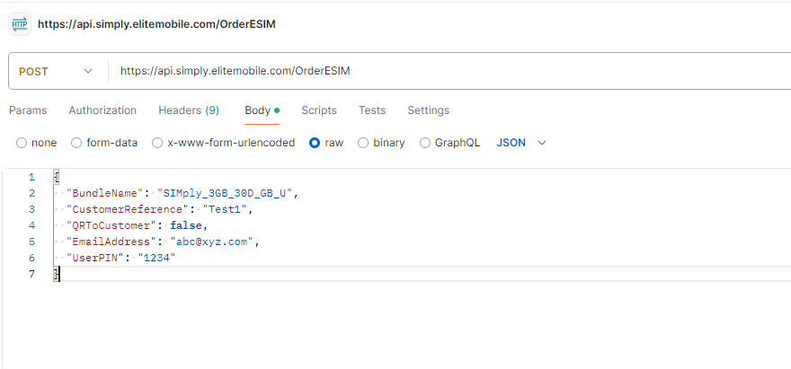
Request and Response would be in JSON Format.
Possible Request
POST Object.
{
"BundleName": "SIMply_3GB_30D_GB_U",
"CustomerReference": "Test1",
"QRToCustomer": false,
"EmailAddress": "abc@xyz.com",
"UserPIN": ""
}

BundleName: | Bundle that you want to apply and received from GetESIMBundles API.
CustomerReference: | Could be anything that you want to keep as reference for your record.
QRToCustomer: | true/false  - True will send email to the provided email address in this POST object.  - False will send email to the Logged in User’s email address.
EmailAddress: | Email of customer to whom you want to send. System will send email to this only when QRToCustomer is True.
UserPIN: | Logged In User pin provided by SIMply. Same as used for SIMply Web and SIMply App

Note: Email Configuration/Setup required for your account when you are selecting QRToCustomer as True.

Possible Responses
{
"Status": 0,
"Message": "Invalid Token",
"PageCount": 0,
"PageSize": 0,
"Rows": 0,
"TotalPages": 0
}
Response Code: 401

{
"Status": 1,
"Message": "ESIM Ordered Successfully. You will get all the details in your email address ",
}
Response Code: 200

Success ("Status": 1)
- ESIM Ordered Successfully. You will get all the details in your email address abc@xyz.com
Failure ("Status": 0)
- Out Of Service. Please contact your administrator.
- You are not allowed for ESIM. Please contact your administrator.
- Invalid Account Details
- No Data Found.
- Please provide valid customer email address.
- Please provide valid User PIN.
- Invalid PIN. Please enter correct PIN.
- User is not allowed to Purchase ESIM. Please contact your administrator.
- Please setup the Email Configuration first to send QR to Customer. (Accounts > Email Configuration)
- Please select at least one bundle to purchase ESIM.
- Bundle for this Country is not available. Please select another bundle and try again.
- Invalid Bundle Details. Please select the Bundle again
- You have low balance to Purchase this ESIM. Please contact your administrator.
- OOPS! Something went wrong. Please select another bundle and try again. Order was Unsuccessful.
Response Code: 200

ViewESIMOrderDetails:
POST API.
https://api.simply.elitemobile.com/ViewESIMOrderDetails
You can view the Order Details, Bundle Details, Bundle Usage.
Token need to be passed in Header generated through above GenerateToken API.
“Content-Type” having value “application/json”
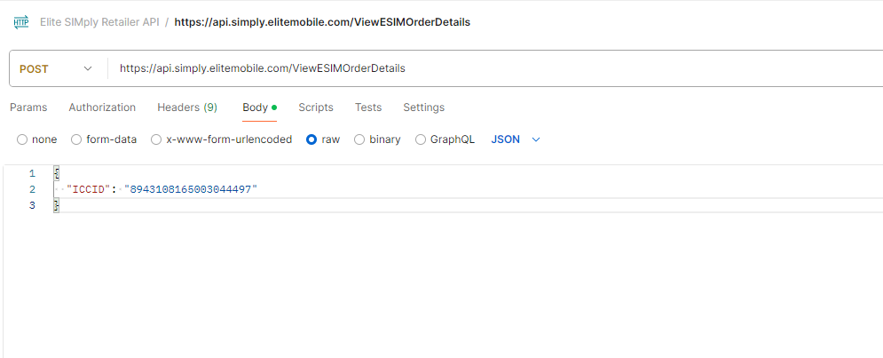

Request and Response would be in JSON Format.
Possible Request
POST Object.
{
"ICCID": " 8943108165003044497"
}

ICCID: | The unique ID of eSIM that is generated while Order ESIM. You can found it in ESIM Order Report from SIMply Web or SIMply App.  Reporting > ESIM Order Report.

Possible Responses
{
"Status": 0,
"Message": "Invalid Token",
"PageCount": 0,
"PageSize": 0,
"Rows": 0,
"TotalPages": 0
}
Response Code: 401

{
"ICCID": "string",
"ActivationCode": "string",
"SMDPAddress": "string",
"ProfileStatus": "string",
"PIN": "string",
"PUK": "string",
"FirstInstallationDateTime": "string",
"BundleDescription": "string",
"QRCode": "string",
"IsBundleUsed": boolean,
"IsRefunded": boolean,
"CountryActivated": "string",
"InitialQuantity": int,
"RemainingQuantity": int,
"AssignmentStartTime": "string",
"AssignmentEndTime": "string",
"ProgressPercentage": decimal,
"ExpiresInDays": int,
"UsedDaysPercentage": decimal,
"GBUsed": decimal,
"TotalGB": decimal,
"Status": 1,
"Message": "Success"
}

Response Code: 200

Success ("Status": 1)
- Success
Failure ("Status": 0)
- Out Of Service. Please contact your administrator.
- You are not allowed to View ESIM. Please contact your administrator.
- Invalid Account Details
- No Data Found.
Response Code: 200

RevokeESIMOrder:
POST API.
https://api.simply.elitemobile.com/RevokeESIMOrder
You can revoke the Order by using this API. Bundle should not be used/activated.
Token need to be passed in Header generated through above GenerateToken API.
“Content-Type” having value “application/json”
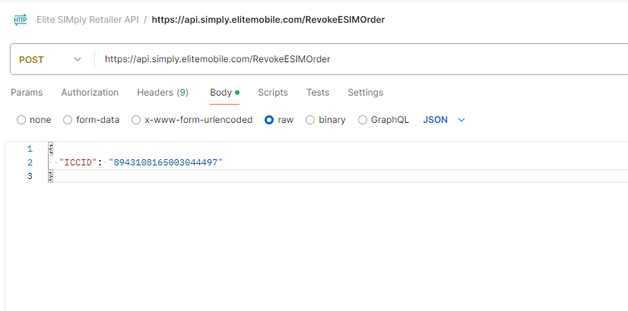
Request and Response would be in JSON Format.
Possible Request
POST Object.
{
"ICCID": " 8943108165003044497"
}

ICCID: | The unique ID of eSIM that is generated while Order ESIM. You can found it in ESIM Order Report from SIMply Web or SIMply App.  Reporting > ESIM Order Report.

Possible Responses
{
"Status": 0,
"Message": "Invalid Token",
"PageCount": 0,
"PageSize": 0,
"Rows": 0,
"TotalPages": 0
}
Response Code: 401

{
"Status": 1,
"Message": " Revoked Successfully"
}

Response Code: 200

Success ("Status": 1)
- Success
Failure ("Status": 0)
- Out Of Service. Please contact your administrator.
- You are not allowed to Revoke ESIM. Please contact your administrator.
- Invalid Details
- Invalid Account Details
- ESIM Order Not Found.
- You cannot revoke this ESIM Order as it is already Revoked.
- You cannot revoke this ESIM Order as sim is installed and Bundle is activated for it.
- !OOPS, Something went wrong.
Response Code: 200

TopupRecharge
List of API for TopupRecharge
- GetNetworks
- ConfirmContact
- RechargeTopup

GetNetworks:
GET API.
https://api.simply.elitemobile.com/GetNetworks
You will receive list of all the active networks assigned to you by SIMply.
Token need to be passed in Header generated through above GenerateToken API.
“Content-Type” having value “application/json”

Request and Response would be in JSON Format.
Possible Responses
{
"Status": 0,
"Message": "Invalid Token",
"PageCount": 0,
"PageSize": 0,
"Rows": 0,
"TotalPages": 0
}
Response Code: 401

{
"NetworkList": [
{
"NetworkId": 3,
"NetworkName": "3",
"NetworkImage": "https://simply.elitemobile.com/Content/Images/Networks/Three.png",
"EPINNetwork": "Yes"
},
…….
],
"Status": 1,
"Message": "Success",
"PageCount": 1,
"PageSize": 1,
"Rows": 4,
"TotalPages": 1
}
Response Code: 200

Success ("Status": 1)
- Success
Failure ("Status": 0)
- Out Of Service. Please contact your administrator.
- You are not allowed to TopUp. Please contact your administrator.
- Invalid Account Details
- No Data Found.
Response Code: 200

ConfirmContact:
POST API
https://api.simply.elitemobile.com/ConfirmContact
You have to call this Confirm Contact API before the final Recharge Topup API call.
In this API, you can validate your Contact Number and get available offers for your Contact Number.
You will get List of Topups and Bundles available to your Contact Number. This information will be needed in Recharge Topup API.

Token need to be passed in Header generated through above GenerateToken API.
“Content-Type” having value “application/json”
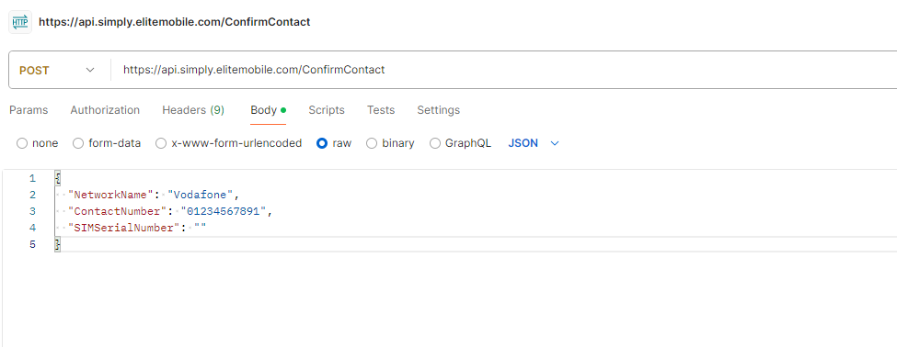

Request and Response would be in JSON Format.
Possible Request
POST Object
{
"NetworkName": "Vodafone",
"ContactNumber": "11-digit contact number",
"SIMSerialNumber": ""
}

NetworkName: | Network Name for which you want to do Topup. You can get it from GetNetworks API.
ContactNumber: | 11 Digit Contact Number for which you want to do Topup.  Works with all Network.
SIMSerialNumber: | 18 Digit SIM Serial Number for which you want to do Topup.  Works with only Three Network.

Note: Here, Contact Number and SIM Serial Number from both only 1 number is required.
For SIM Serial Number, please make sure its belongs to Elite repository and only valid with Three Network.

Possible Responses
{
"Status": 0,
"Message": "Invalid Token",
"PageCount": 0,
"PageSize": 0,
"Rows": 0,
"TotalPages": 0
}
Response Code: 401

{
"TopUpList": [
{
"Description": "(Vodafone) Pay as you go £10",
"TopUpValue": 10
},
........
],
"BundleList": [
{
"BundleName": "(Vodafone) Big Value Bundle £10",
"BundleValue": 10.00,
"BundleProductCode": "5033901078842"
},
……..
],
"NetworkName": "Vodafone",
"Status": 1,
"Message": "Success"
}

Response Code: 200

Success ("Status": 1)
- Success
- Topup List
- Bundle List
- NetworkName

Failure ("Status": 0)
- Out Of Service. Please contact your administrator.
- You are not allowed to TopUp. Please contact your administrator.
- Invalid Account Details
- No Data Found.
- Please provide valid Network Name
- Invalid Network. Please provide valid Network Name.
- You can select SIM Serial Number for Three Network Only. Please select either Contact Number or SIM Serial Number.
- You are not allowed for any Network. Please contact your administrator.
- Please provide valid Contact Number
- Please provide valid SIM Serial Number
- You are not allowed to do recharge for same Contact Number within 1 minutes. Please wait for 1 minutes otherwise select another Contact Number and try again.
- Enterted number is already topup done in last 30 days. (Three Network)
- Enterted number is already topup done today. (Other than Three Network)
- Entered SIM Number is not an Elite Sim Card so we can't continue with the topup. Please enter another SIM Number and try again.
- Three Network are experiencing problems. Please try again after sometimes.
- Please enter a valid Three Network number
- !OOPS, Something went wrong with 3 Network. Please try again after sometime or you can continue to topup with another Network.
- Please provide valid details
Response Code: 200

RechargeTopup:
POST API
https://api.simply.elitemobile.com/RechargeTopup
You can do Topup with this Recharge Topup API for the selected network, topup and bundle.
You can get available Networks information from GetNetworks API.
You can get available Topups and Bundles information from ConfirmContact API.

Token need to be passed in Header generated through above GenerateToken API.
“Content-Type” having value “application/json”
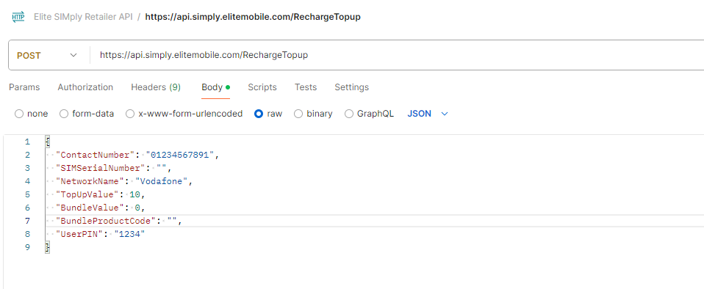
Request and Response would be in JSON Format.
Possible Request
POST Object
{
"ContactNumber": "11-digit Contact Number",
"SIMSerialNumber": "18-digit SIM Serial Number",
"NetworkName": "Vodafone",
"TopUpValue": 10,
"BundleValue": 10,
"BundleProductCode": "5033901078842",
"UserPIN": "1234"
}
ContactNumber: | 11-digit Contact Number for which you want to do Topup.  Valid with all Networks
SIMSerialNumber: | 18-digit SIM Serial Number for which you want to do Topup.  Valid with only Three Network.
NetworkName: | Network Name for which you want to do Topup. You can get it from GetNetworks API.
TopUpValue: | Topup Decimal Value that you want to do Topup. You can get available Topups from ConfirmContact API.
BundleValue: | Optional.  Bundle Decimal Value that you want to do Topup. You can get available Bundles from ConfirmContact API.
BundleProductCode: | Optional.  Bundle Product Code that you want to do Topup. You can get available Bundles from ConfirmContact API.
UserPIN: | Logged In User pin provided by SIMply. Same as used for SIMply Web and SIMply App

Note: Here, from Contact Number and SIM Serial Number, only 1 number is required.
For SIM Serial Number, please make sure its belongs to Elite repository and only valid with Three Network.
For Three Network, you can do only Topup and Topup with Bundle.
For Other Network, you can do either Topup or Bundle.

Possible Responses
{
"Status": 0,
"Message": "Invalid Token",
"PageCount": 0,
"PageSize": 0,
"Rows": 0,
"TotalPages": 0
}
Response Code: 401

{
"Status": 1,
"Message": " Top Up done successfully"
}

Response Code: 200

Success ("Status": 1)
- Top Up done successfully

Failure ("Status": 0)
- Out Of Service. Please contact your administrator.
- You are not allowed to TopUp. Please contact your administrator.
- Invalid Account Details / Invalid Details
- No Data Found.
- Please provide valid User PIN.
- Invalid PIN. Please enter correct PIN.
- Please provide valid Network Name
- Invalid Network. Please Select Valid Network.
- You are not allowed for any Network. Please contact your administrator.
- You can select SIM Serial Number for Three Network Only. Please select either Contact Number or SIM Serial Number.
- User is not allowed to TopUp. Please contact your administrator.
- You have low balance to do this recharge. Please contact your supervisor.
- Credit Balance is Below £10 so top ups or bundles are not available. Please speak to a supervisor.
- You have reached your top up allowance. Please speak to your account manager should you require an increased limit.
- Please provide valid Mobile Number
- Please provide valid SIM Serial Number
- Entered SIM Number is not an Elite Sim Card so we can't continue with the topup. Please enter another SIM Number and try again.
- Please select Topup or Bundle and try again.
- Please select valid Topup or Bundle and try again.
- Please select either Topup or Bundle and try again.
- Bundle Requested is greater than Top-Up Value. Please provide valid Details.
- Selected Topup is Invalid and Please select another Topup and try again.
- Selected Bundle is Invalid and Please select another Bundle and try again.
- Please provide values for both - Bundle Value and Bundle Product code.
- You are not allowed to do recharge for same Contact Number within 1 minutes. Please wait for 1 minutes otherwise select another Contact Number and try again.
- Entered number is already topup done in last 30 days.
- Entered number is already topup done today.
- You cannot topup this Number. Please contact your Administrator.
- Three Network are experiencing problems. Please try again after sometimes.
- Please enter a valid Three Network number
- OOPS! Something went wrong. Please select another topup or bundle and try again. Top Up was Unsuccessful.

Response Code: 200

Network ESIM
List of API for Network ESIM
- GetESIMNetworks
- GetESIMTopupBundles
- PurchaseNetworkESIM

GetESIMNetworks:
GET API.
https://api.simply.elitemobile.com/GetESIMNetworks
You will receive Network list available for ESIM in SIMply with Image details.
API will not need any Parameters. It’s just need token to be passed in Header generated through above GenerateToken API.
Access Token can be passed only in header and cannot be passed in the request param.
Header name should be “Authorization”
Header value should be bearer {access_token}

you need to pass “Authorization” having value “Bearer (Token Received)”.
“Content-Type” having value “application/json”
Here, Bearer is fixed word then space then Token received in Token API.

Request and Response would be in JSON Format.
Possible Responses
{
"Status": 0,
"Message": "Invalid Token",
"PageCount": 0,
"PageSize": 0,
"Rows": 0,
"TotalPages": 0
}

Response Code: 401

{
"NetworkList": [
{
"Name": "3",
"AbbreviationName": "3",
"NetworkImage": " https://simply.elitemobile.com/Content/Images/networks/Three.png"
},
{
"Name": "O2",
"AbbreviationName": "O2",
"NetworkImage": " https://simply.elitemobile.com/Content/Images/networks/O2.png"
}
],
"Status": 1,
"Message": "Success",
"PageCount": 1,
"PageSize": 0,
"Rows": 2,
"TotalPages": 0
}

Response Code: 200
Success ("Status": 1)
- Success
Failure ("Status": 0)
- Out Of Service. Please contact your administrator.
- You are not allowed for Network ESIM. Please contact your administrator.
- Invalid Account Details
- No Data Found.
Response Code: 200

GetESIMTopupBundles:
POST API.
https://api.simply.elitemobile.com/GetESIMTopupBundles
You will receive eSIM Topup and Bundle list available in SIMply with details.
Token need to be passed in Header generated through above GenerateToken API.
“Content-Type” having value “application/json”
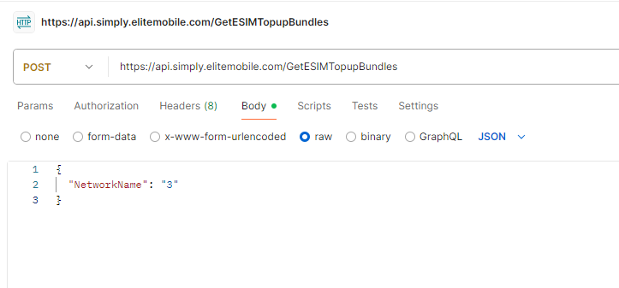

Request and Response would be in JSON Format.
Three Network Possible Request
POST Object.
{
"NetworkName": "3"
}

NetworkName: | Network Name that is received in above GetESIMNetwokrs API under the Name field.

Possible Responses
{
"Status": 0,
"Message": "Invalid Token",
"PageCount": 0,
"PageSize": 0,
"Rows": 0,
"TotalPages": 0
}
Response Code: 401

{
"TopUpList": [
{
"Description": "TopUp E-Voucher",
"TopUpValue": 10
},
{
"Description": "TopUp E-Voucher",
"TopUpValue": 20
}
],
"BundleList": [
{
"BundleName": "10GB Data Pack",
"BundleValue": 10,
"BundleProductCode": "312237"
},
{
"BundleName": "60GB Data Pack",
"BundleValue": 15,
"BundleProductCode": "633418"
}

]

]
"Status": 1,
"Message": "Success",
"PageCount": 1,
"PageSize": 0,
"Rows": 8,
"TotalPages": 1
}
Response Code: 200

O2 Network Possible Request
POST Object.
{
"NetworkName": "O2"
}

NetworkName: | Network Name that is received in above GetESIMNetwokrs API under the Name field.

Possible Responses
{
"Status": 0,
"Message": "Invalid Token",
"PageCount": 0,
"PageSize": 0,
"Rows": 0,
"TotalPages": 0
}
Response Code: 401

{
"TopUpList": [
{
"Description": "O2 P&G 24GB DATA BB eSIM",
"TopUpValue": 10
},
{
"Description": "O2 P&G 75GB DATA BB eSIM",
"TopUpValue": 15
},
{
"Description": "O2 P&G 40GB DATA BB eSIM",
"TopUpValue": 20
},
{
"Description": "O2 P&G 125GB DATA BB eSIM",
"TopUpValue": 30
}
],
"BundleList": [],
"Status": 1,
"Message": "Success",
"PageCount": 1,
"PageSize": 0,
"Rows": 4,
"TotalPages": 0
}
Response Code: 200

Success ("Status": 1)
- Success
Failure ("Status": 0)
- Out Of Service. Please contact your administrator.
- You are not allowed for Network ESIM. Please contact your administrator.
- Invalid Account Details
- No Data Found.
- Please provide valid Network Name
- Invalid Network. Please provide valid Network Name.
- ESIM is not available. Please contact your administrator.
- You are not allowed for any Network. Please contact your administrator.
- Three Network are experiencing problems. Please try again after sometimes.
- !OOPS, Something went wrong with 3 Network. Please try again after sometime or you can continue to topup with another Network.
Response Code: 200

PurchaseNetworkESIM:
POST API
https://api.simply.elitemobile.com/PurchaseNetworkESIM
You can do purchase Network ESIM and Topup with this API for the selected network, topup and bundle.
You can get available Networks information from GetESIMNetworks API.
You can get available Topups and Bundles information from GetESIMTopupBundles API.

Token need to be passed in Header generated through above GenerateToken API.
“Content-Type” having value “application/json”
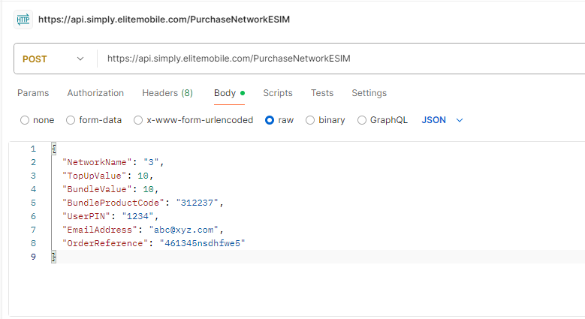
Request and Response would be in JSON Format.
Possible Request
POST Object (Three Network Example)
{
"NetworkName": "3",
"TopUpValue": 10,
"BundleValue": 10,
"BundleProductCode": "312237",
"UserPIN": "1234",
"EmailAddress": "abc@xyz.com",
"OrderReference": "461345nsdhfwe5"
}

POST Object (O2 Network Example)
{
"NetworkName": "O2",
"TopUpValue": 10,
"BundleValue": "",
"BundleProductCode": "",
"UserPIN": "1234",
"EmailAddress": "abc@xyz.com",
"OrderReference": "461345nsdhfwe5"
}

NetworkName: | Network Name for which you want to purchase and do Topup. You can get it from GetESIMNetworks API.
TopUpValue: | Topup Decimal Value that you want to do Topup. You can get available Topups from GetESIMTopupBundles API.
BundleValue: | Optional.  Bundle Decimal Value that you want to do Topup. You can get available Bundles from GetESIMTopupBundles API.
BundleProductCode: | Optional.  Bundle Product Code that you want to do Topup. You can get available Bundles from GetESIMTopupBundles API.
UserPIN: | Logged In User pin provided by SIMply. Same as used for SIMply Web and SIMply App
Email Address: | Optional.  Email address that you want to send purchased ESIM details and barcode in the email.  Can be multiple valid emails with Comma separated and without space.  Ex. abc@xyz.com,pqr@xyz.com  By default it will send to User and Store’s Email Addresses.
Order Reference: | Optional.  Your unique Order Reference number. It will check if same order already processed with us then it will consider as duplicated and will not process same order next time.

Note:
For Three Network, you can do only Topup and Topup with Bundle.
For O2 Network, you can do TopUp only. It will auto consider Bundle/Data mapped with the TopUp.
For Other Network, you can do either Topup or Bundle.

Possible Responses
{
"Status": 0,
"Message": "Invalid Token",
"PageCount": 0,
"PageSize": 0,
"Rows": 0,
"TotalPages": 0
}
Response Code: 401

Three Network Response Example
{
"ContactNumber": "07865216463",
"ICCID": "8944200234752000056",
"QRCode": " https://simply.elitemobile.com/ESIMQRCodeImages/847fee44d5d5d2ab5b0072e9b5b8979c.png",
"ActivationCode": "00XGD8PRWQPOTP70",
"SMDPAddress": "huk.prod.ondemandconnectivity.com",
"PIN": "4031",
"EmailAddress": "abc@xyz.com",
"TopupValue": 0,
"BundleDescription": "10GB Data Pack",
"InstallLink": "https://esimsetup.apple.com/esim_qrcode_provisioning?carddata=LPA:1$huk.prod.ondemandconnectivity.com$00XGD8PRWQPOTP70$$1",
" InstallLinkAndroid": "https://esimsetup.android.com/esim_qrcode_provisioning?carddata=LPA:1$huk.prod.ondemandconnectivity.com$00XGD8PRWQPOTP70$$1",
"OrderReference": "461345nsdhfwe5",
"Status": 1,
"Message": "Top Up done successfully"
}

O2 Network Response Example
{
"ContactNumber": "07865216463",
"ICCID": "8944200234752000056",
"QRCode": " https://simply.elitemobile.com/ESIMQRCodeImages/847fee44d5d5d2ab5b0072e9b5b8979c.png",
"ActivationCode": "00XGD8PRWQPOTP70",
"SMDPAddress": "cel.prod.ondemandconnectivity.com",
"PIN": "4031",
"EmailAddress": "abc@xyz.com",
"TopupValue": 10,
"BundleDescription": " O2 P&G 8GB DATA BB eSIM",
"InstallLink": "https://esimsetup.apple.com/esim_qrcode_provisioning?carddata=LPA:1$huk.prod.ondemandconnectivity.com$00XGD8PRWQPOTP70$$1",
"InstallLinkAndroid": "https://esimsetup.android.com/esim_qrcode_provisioning?carddata=LPA:1$huk.prod.ondemandconnectivity.com$00XGD8PRWQPOTP70$$1",
"OrderReference": "461345nsdhfwe5",
"Status": 1,
"Message": "Top Up done successfully"
}

Response Code: 200

Success ("Status": 1)
- Top Up done successfully

Failure ("Status": 0)
- Out Of Service. Please contact your administrator.
- Invalid Request. Please try again.
- You are not allowed to purchase Network ESIM. Please contact your administrator.
- Invalid Account Details / Invalid Details
- No Data Found.
- Duplicate Order will not be processed. Please select another Order.
- ESIM is not available. Please contact Administrator.
- Please provide valid User PIN.
- Invalid PIN. Please enter correct PIN.
- Please provide valid Network Name
- Invalid Network. Please Select Valid Network.
- Please provide valid Topup Value
- Please provide valid Bundle Product Code
- Please provide valid Email Address
- You are not allowed for any Network. Please contact your administrator.
- You are not allowed to do any Recharge. Please contact your administrator.
- User is not allowed to TopUp. Please contact your administrator.
- You have low balance to do this recharge. Please contact your supervisor.
- Credit Balance is Below £10 so top ups or bundles are not available. Please speak to a supervisor.
- You have reached your top up allowance. Please speak to your account manager should you require an increased limit.
- Invalid ESIM. Please try again after sometime.
- This ESIM is already used. Please try again to purchase new ESIM.
- Please select Topup or Bundle and try again.
- Please select valid Topup or Bundle and try again.
- Please select either Topup or Bundle and try again.
- Bundle Requested is greater than Top-Up Value. Please provide valid Details.
- Please provide valid TopUp and Bundle Details for Three Network.
- Selected Topup is Invalid and Please select another Topup and try again.
- Selected Bundle is Invalid and Please select another Bundle and try again.
- Please provide values for both - Bundle Value and Bundle Product code.
- You are not allowed to do recharge for same Contact Number within 1 minutes. Please wait for 1 minutes otherwise select another Contact Number and try again.
- Entered number is already topup done in last 30 days.
- Entered number is already topup done today.
- You cannot topup this Number. Please contact your Administrator.
- Three Network are experiencing problems. Please try again after sometimes.
- Please enter a valid Three Network number
- OOPS! Something went wrong. Please select another topup or bundle and try again. Top Up was Unsuccessful.

Response Code: 200

